A Study of Oracle Systems for the QTUM Blockchain Eco-system.
By
Mr. George John Chavady

A Dissertation
submitted to the University of Dublin, in partial fulfilment of the requirements for the
degree of
Master of Science in Computer Science (Intelligent Systems)

Supervisor: Prof. Donal O’ Mahony
August 2020

Declaration

I declare that the work described in this dissertation is, except where otherwise stated, entirely my own work, and has not been submitted as an exercise for a degree at this or any other university.

Signed:

George John Chavady
26/08/2020

Permission to lend and/or copy

I agree that the Trinity College Library may lend or copy this dissertation upon request.

Signed:

George John Chavady
26/08/2020

Acknowledgments

First and foremost, I would like to thank God Almighty for helping me complete my research. Next, I would like to express my sincere gratitude to my supervisor, Prof. Donal O’Mahony for his continuous support, guidance, encouragement and expertise during my master’s thesis.
I also thank my parents Mr. John Cherian and Mrs. Aneyamma John, for all their support and love during the period of my course. I am very grateful to Mr. Manoj George, my uncle for his support during my stay in Ireland. My brother Paul John and Elizabeth John have always been a pillar of support.

George John Chavady
University of Dublin, Trinity College
August 2020

Table of Contents
Contents viii
List of Figures x
List of Tables xii
- Introduction 1
  - Motivation
  - Research Question
  - Research Challenges
  - Thesis Overview
  - Thesis Structure
- Literature Review
  - Blockchain
  - Bit-coin
    - UTXO model
    - Proof-of-Work algorithm
    - Merkel Trees
  - Ethereum
    - Accounts in Ethereum
    - Messages and Transactions
    - Turing Completeness in Ethereum
  - QTUM blockchain
    - Account Abstraction Layer
    - Proof-of-Stake algorithm
  - Smart Contracts and DApps
    - Contract components
    - Contract development
    - Contract deployment
- Oracles in Blockchain
  - Introduction to Oracles
  - Centralized Oracles
    - Provable
    - Town Crier
  - Decentralized Oracles
    - Astrea
    - Chain Link
    - Augur
  - A Summary of Oracles
  - Use Cases
- Design
4.1
4.2
4.3
- Implementation
5.1
5.2
5.3
- Evaluation
6.1
6.2
6.3
- Conclusion
7.1
7.2
Bibliography

Chapter 1

Introduction
The world presents to us a number of use cases that require decentralization. For example, consider a travel insurance policy that provides a cover for travel delay. The data critical to verify whether a flight has been delayed, is the scheduled departure time and actual departure time. The process of claims payment can be digitised using a software application. But the application could be easily manipulated by a person with access permissions, either by altering the code or the data used by the claims payment system, and hence prone to fraud. In our case the variable ‘Actual Departure Time’ can be altered to make a false payment. The solution is to implement a decentralized and immutable system where all the state changes are stored permanently, and no single person has complete authority over the system.
Blockchain is a technology that combines the qualities of decentralization and immutability. It achieves decentralization using a peer-to-peer network to connect all the users of the system, and each member of the network equally participates to reach a consensus. Each communication in the network is recorded as a transaction and stored permanently in the network. It uses various types of consensus protocols to reach an agreement on whether a transaction is valid. There is no single entity that fully controls the operation in the blockchain. The cryptography techniques and incentive schemes are carefully designed to help create a distributed ledger shared by all the members of the network and is immutable.
By design, the blockchain network has no central authority with the ability to unilaterally approve invalid transactions or roll back and alter the state of previous transactions. Although, there are some blockchains that allow only one user to mine blocks, which are called private blockchains. The distributed ledger stored on every user’s machine is an append-only log for storing data in an immutable manner. A new transaction is only added at the end of the ledger, and no previous transactions can be modified. Each user possesses a private key that is used to authorize transactions, preventing forgery. Moreover, a new transaction is not immediately added to the ledger but is bundled together with other pending transactions into a block. This is done to prevent double spending attacks which refers to the same currency used more than once in several transaction. [1]
There are several blockchains such as Bitcoin, Ethereum, Quorum, Hyperledger etc. Ethereum was the first blockchain that supported the implementation of smart contracts. A Smart Contract is a program deployed in a distributed network that can acquire outside information and update its internal state automatically. [4] The ultimate goal of the smart contract is to use computer intelligence instead of human intelligence to make the system more efficient and credible.
1.1 Motivation
The true potential of a smart contract can be exploited when data can be made available to the decentralised system in which the smart contract is deployed from the outside world. An oracle is an entity which provides trustworthy information from a service that is external to a blockchain. E.g., Suppose that George and Paul place a bet on who the winner of the US presidential election will be. George believes that the Republican candidate will win, while Paul believes that the Democrat will be the winner. They agree on the terms of the bet and lock their funds in a smart contract, which will release all the funds to the winner based on the results of the election.
Since the smart contract is passive and cannot interact with external data, it has to be supplied with the necessary information by an entity that has access to the outside world. This entity is called an oracle. After the election is over, the oracle queries a trusted API on behalf of the parties involved in the contract to find out which candidate has won and relays this information to the smart contract. The contract then sends the funds to Alice or Bob, depending on the outcome, more importantly depending on the data sent by the oracle service. Without the oracle relaying the data, there would not have been a way to settle this bet by transfer of funds. It has to be noted that the efficiency of the oracle service is quintessential to the proper working of the smart contract. If the service opts to send data that is false, this could result in funds being transferred to the wrong party. [9]
Several oracle solutions are currently available in the market. Oraclize.it [6] fetches data from a specified web source and publishes it to a blockchain application. They also maintain cryptographic proofs which show that the information originated from the correct source. Town Crier [7] is another oracle, which works in a similar fashion.
It makes use of Intel Software Guard Extensions [8] to protect against tampering.
Oracles are essential implementations in numerous applications where there is a need for data that is external to be brought into the blockchain. The current oracles provide a solution without robust security guarantees that the blockchain provides. These therefore are impediments to security and could possibly become centralized pointsof-failure or attack. Thus, the oracles in the Blockchain eco-system remain a subject of research and innovation. In this work we explore the existing literature and state of the art in blockchain, decentralized applications and oracles in block chain. We also aim to work on designing an Oracle system that improves upon existing architectures.
1.2 Research Question
Can we find an improvement upon existing oracle implementations in the blockchain eco-system?
1.3 Challenges
- Lack of substantial literature on Oracles and their implementations.
- Bringing innovation to the existing work on Oracles.
- Insufficient documentation for oraclize.it service and other oracles.
- Fewer implementations of smart contracts and oracles available on the web or other resources.
- Compatibility of solidity compilers was often an issue. Hence, had to avoid using compilers having versions greater than 4.25.
1.4 Overview
The use of oracles to send data that is external, into the blockchain is critical to the proper functioning of smart contracts deployed within a blockchain. The concept of oracles is an interesting development in the blockchain industry. In order to gain a proper understanding of the working of oracles, it is important to understand the state of the art in blockchain. This work consists of review of Bitcoin and Ethereum blockchain concepts. Bitcoin blockchain uses a design that implements decentralization and immutability to manage the bitcoin currency. Unlike Bitcoin that allows only simple operations to be performed to ensure security, Ethereum also allows code of complex nature to be executed on the blockchain. Further, we understand the QTUM blockchain eco-system that uses the best of both Bitcoin and Ethereum blockchains. QTUM provides a Turing-complete blockchain stack that can execute smart contracts and decentralized applications and, uses the Ethereum Virtual Machine (EVM). However, in contrast to Ethereum, QTUM is built upon Bitcoin’s Unspent Transaction Output (UTXO) model and employs a Proof-of-stake consensus mechanism that is more practical for business adoption. A transaction in the blockchain consists of inputs and outputs. The outputs that have not been spent yet are referred to as UTXOs. We examine the various oracles currently available in the market and categorises them as centralized and decentralized. The work also explains implementations of smart contracts and oracles on the Ethereum blockchain. An innovation from the existing implementations of oracles has also been discussed and designed which is the contribution to the literature on Oracles for blockchain.

1.5 Thesis Structure
The thesis is organized as follows. Chapter 2 presents the literature review on
Blockchain, Bitcoin Core, Ethereum and Smart Contracts. Chapter 3 examines the work on Oracles in blockchain. Chapter 4 focuses on the design aspects of various Oracles that are currently existing. Chapter 5 discusses the implementation of smart contracts and oracles that interact with the contracts deployed in the Ethereum blockchain. It also discusses a few innovations with respect to oracles and their design. Chapter 6 evaluates the newly proposed design of oracles and checks for feasibility. The last section consists of conclusion and future works or research.
Chapter 2

Literature Review
2.1 Blockchain
Todays’ payment systems facilitate an exchange of currency between two entities namely a payer and a payee. Apart from the payer and payee, a payment system typically involves two more entities that act on behalf of the parties involved in the transaction. One entity manages funds on behalf of the payer, known as the issuing bank (or issuer), and another entity that maintains an account for the payee, known as the acquiring bank or acquirer.
The operations of a typical cash-like system (traditional banking system) are depicted in Figure 2.1. In a cash-like system, the payer’s account is charged a fee before the actual payment takes place. Transactions require that a payment be made to the intermediary bank which usually is a percentage of the amount that the payer wishes to transfer. Businesses need to expend their profits towards high banking fees when the total amount transferred and the number of transactions increase. [7] Further, the amount is transferred through intermediaries and organisations that maintain their own logs with unrestricted access to alter them. Blockchain improves the payment system by ensuring and assuring parties of security through immutability, higher transfer speeds, lower conversion fees and a trustless service. This is achieved first and foremost by eliminating the need for centralized control (e.g., by banks) to transfer funds and perform third-party authorizations through the implementation of a shared distributed ledger. The distributed ledger is an append only log that stores all the transactions that occur, with a guarantee that they cannot be altered. Security is enforced by maintaining a hash of the previous block within every block such that the genesis (or the first) block can be verified. These transactions are made public so that all the stake holders could access them and check for integrity if needed. It requires only the parties involved to authorize using a private key.
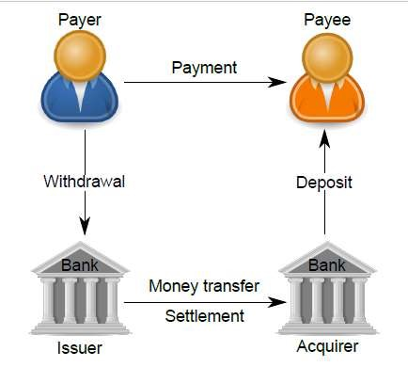
Figure 1: Cash-like Payment System Architecture

More formally, a blockchain can be defined as a system that decentralizes the working of an application where there is no single entity that controls the operation of the blockchain. The network has no central authority that is able to unilaterally approve invalid transactions or manipulate the state of the system through any means aside from normal submission of transactions for processing. The system uses a distributed ledger for storing the transactions. A new transaction can be added only at the end of the ledger, and no previous transactions can be modified. Moreover, a new transaction is not immediately added to the ledger but is bundled together with other pending transactions into a block. [1]
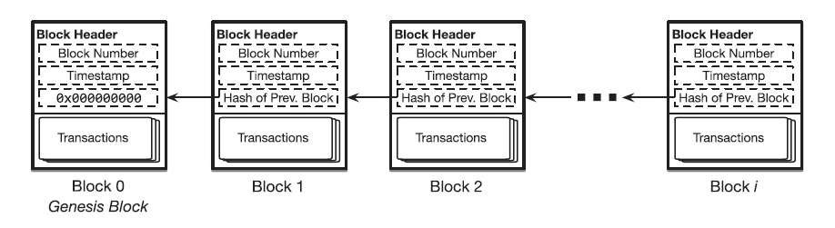
Figure 2: A Simple Blockchain

Blockchain as a Ledger
Blockchain is a distributed ledger technology which consists of three elements. First, the ledger is continuously amended and persistent, where all transactions effected on the blockchain are perpetually stored. Secondly, a blockchain is a distributed peer to peer ledger, where an entire copy of the blockchain is stored on every node in the network. If new transactions are affected, majority of nodes in the network must verify the legitimacy of the effected transaction and, if confirmed, every node is updated with the transaction. With this distributed authentication process, the core feature of blockchain which is the lack of a central entity or intermediary is facilitated. And thirdly, blockchain is asymmetrically encrypted and requires private and public keys to make a transaction. [9]
For example, Bitcoin technology uses a ledger to record the transactions and also track the ownership of tokens called Bitcoins. The tokens are distributed among nodes that represent accounts that are each uniquely identified by a public key. Bitcoin associates a public key with a balance in Bitcoins. Each item added to Bitcoin’s blockchain-backed ledger serves as a record of a transaction which denotes a transfer of Bitcoins from one public key to another.
2.2 Bitcoin
Bitcoin is a blockchain that supports the working of the bitcoin cryptocurrency. In Bitcoin, payments are performed by issuing transactions that transfer Bitcoin coins, referred to as BTCs, from the payer to the payee. Both payers and payees are peers in the network and are referenced in transactions by Bitcoin addresses. Each address of a peer in the network is mapped to a unique public/private key pair, which is used to transfer ownership of BTCs among addresses. A private key in bitcoin is a large random number between 1 and 2 ^ 256, which could take an attacker billions of years to try all possible combinations. An Elliptic Curve Digital Signature algorithm (ECDSA) on the private key is used to generate a public key. Users are able to generate public/private key pairs and the bitcoin address is a fixed length binary quantity of 26 to 35 alphanumeric characters which is derived from the public key.
The bitcoin blockchain operates on top of a loosely connected peer-to-peer network, where users can join and leave the network as they wish. The peers or users connect to the blockchain network by requesting a list of current bitcoin peer addresses from the Domain Name System seeds. DNS is a protocol that maps domain names to IP addresses of users connected to the network. For example, the domain name www.oracle.com translates to the addresses 91.182.212.36 (IPv4). [15] Each Bitcoin address is computed from an ECDSA on the public key, for which the address owner knows the corresponding private key using a transformation based on hash functions. Hashes are one-way functions which allow the computation of the address using the public key but makes it infeasible to retrieve the public key from the address alone.
A Bitcoin transaction is created by digitally signing a hash of the previous transaction outputs, together with the public key of the recipient and referencing them as inputs. The output is a list of addresses that can collect the coins transferred by the transaction. A transaction output can only be redeemed once, after which the output is no longer available to other transactions. This process is facilitated in bitcoin by the implementation of Unspent Transaction Output model (UTXO, see section 2.2.1). The recipient in the transactions is able to redeem the coins using his private key that matches the public key used in the transaction creation process. Once ready, the transaction is signed by the user and broadcast in the P2P network. Any peer can verify the authenticity of a BTCs by checking the chain of signatures using public keys.
The difference between the input and output amounts of a transaction is collected in the form of fees by Bitcoin miners. Miners are peers that participate in the generation of Bitcoin blocks. These blocks are generated by solving a hash-based proof-of-work (PoW) algorithm (see section 2.2.2). More specifically, miners must find a nonce value that, when hashed with additional fields (the Merkle hash (see section 2.2.3) of all valid transactions, the hash of the previous block), the result is below a given target value. If such a nonce is found, miners then include it in a new block, thus allowing any entity to verify the PoW. The underlying proof-of-work allows different miners to find the nonce value and create different blocks nearly at the same time which is when a fork in the blockchain occurs. Forks are inherently resolved by the Bitcoin system through a mechanism where the longest blockchain that is backed by the majority of the computing power in the network will eventually prevail. [7]
2.2.1 UTXO Model
Bitcoin transactions use outputs from previous transactions as inputs in the construction and execution of a new transaction. For example, consider that Alice wants to send Bob 1 bitcoin and the transaction fee required is 0.25 bitcoins. Such a transaction could have the following inputs:
Input 1 – 0.5 BTC
Input 2 – 0.25 BTC
Input 3 – 0.5 BTC
The inputs considered above were outputs from the previous transaction. Considering the transaction fee of 0.25 BTC, the output of the transaction, i.e. the number of bitcoins Bob would actually receive, would be:
Output 1 – 0.5 BTC
Output 2 – 0.5 BTC
Bob would thus receive 1 bitcoin at the end of the transaction. The output of a transaction can either be classified as an unspent transaction output (UTXO) or be classified as spent transaction output. The unspent transaction output later becomes an input for transactions performed by Bob. For transactions such as that of Alice’s to be valid, they must only use unspent transaction outputs as inputs. This validity is checked for by the implementation of a UTXO set.
More formally, an unspent transaction output (UTXO) is an abstraction of electronic money that can be used for future transactions. Each UTXO represents a chain of ownership implemented as a chain of Digital Signatures where the owner signs a message (transaction) transferring ownership of their UTXO to the receiver's Public Key. The receiver node is able to unlock the value sent by the payer using its private key that matches the public key specified within the transaction.

UTXO Set
The function of the UTXO set is that of a global database that shows all the spendable outputs that are available to be used in the construction of a bitcoin transaction. When a new transaction is initiated by a user, it uses an unspent output from the UTXO set of the user, resulting in the set shrinking. On the contrary, when a new unspent output is created (for example, through mining), the UTXO set will grow.
Bitcoin full nodes download every block and transaction to check them against Bitcoin's consensus rules. [13] They are required to track all the unspent outputs in existence on the Bitcoin network in order to ensure that a user is not attempting to spend bitcoins that have already been spent, i.e. a double spending does not take place. To prevent double spending and fraud, inputs on a blockchain are spent when a transaction occurs, while at the same time, outputs are created in the form of UTXOs. These unspent transaction outputs may be used their owners (the holders of private keys) for their future transactions. [14]
A user’s bitcoin balance is the sum of all the individual outputs that can be spent by their private key. Therefore, when a user initiates a transaction, the outputs from the user’s UTXO set is used. All the unspent outputs must entirely be consumed when a transaction is being conducted, with change being sent back if the total value of the outputs is larger than the value of the transaction.
For example, if a user has a UTXO worth 10 bitcoins, but only requires 2 bitcoins for their transaction, then the entire 10 bitcoins is sent with two outputs being produced:
Output 1 – 2 BTC payment to the recipient
Output 2 – 8 BTC payment back to the user’s wallet as change
A transaction consumes previously recorded unspent transaction outputs and creates new transaction outputs that can be used for a future transaction. This allows bitcoins to move from one owner to another, with each transfer consuming and creating
UTXOs in a series of transactions. [12] Components in a Transaction Output
scriptPubKey is a locking script placed on the output of a Bitcoin transaction that requires certain constraints to be satisfied so that a recipient could spend the bitcoins that have been transferred to them. Conversely, scriptSig is the unlocking script that satisfies the conditions placed on the output by the scriptPubKey, and this is what allows the bitcoins to be spent.
Using the previous example, in order for Bob to spend the bitcoins received from Alice, each output will contain a locking script, scriptPubKey, which must first be satisfied by the unlocking script, scriptSig which uses Bob’s private key.
To illustrate, when Alice decides to initiate her transaction with Bob, the outputs that Bob receives contains bitcoins that can be spent only when the conditions laid out by the attached scriptPubKey are satisfied. When Bob decides to spend these outputs, he creates an input that includes an unlocking script, scriptSig, that must satisfy the conditions that Alice placed on the previous outputs using scriptPubKey before he can actually spend them. [12]
2.2.2 Proof of Work
As discussed already, the bitcoin blockchain is maintained by a peer-to-peer network.
The transaction required by a user is executed by the peers in the network. When
users add a new entry to a blockchain’s ledger, they submit a transaction to a node in the network using a Remote Procedure Call (RPC) protocol. The member broadcasts the transaction to the rest of the network for inclusion in a future block. Similarly, a user may submit a query to a network member about the contents of the blockchain’s ledger. The parties involved in a transaction, such as the sender and receiver of Bitcoins on the Bitcoin blockchain do not have complete control of the execution of that transaction. Instead, the task falls to the members of the network who validate the transactions and the miners include the transaction within a block during the block creation process.
The members of the network or the peers can be classified into full nodes and miners. Full nodes are network members that own a full copy of the blockchain, containing every block and thus every ledger item, and keeps this copy synchronized with the latest updates to the blockchain by continuously monitoring the network for notification of new blocks. They help broadcast the transactions of users to the rest of the network. Full nodes commit computation and storage resources to this purpose. Also, by retaining a copy of the blockchain users do not have to trust an intermediary service to query the blockchain’s state or submit transactions on their behalf. A subset of the members within a blockchain’s peer-to-peer network not only maintain copies of the blockchain, but also actively construct and propose new blocks to be added to the chain. This process of constructing and adding new blocks to the network is known as mining, and these members are therefore referred to as miners. Miners must follow a certain protocol to ensure, the property of consensus where all members of the blockchain network together decide on the new block that is to be added to the chain and have an identical view of all previous blocks. This means that all blockchain copies are identical across the network. While there is an additional computational cost to assembling blocks and participating in a consensus protocol, full nodes may choose to run miners, because they have a vested interest in the successful operation of the blockchain or because of more explicit incentives.
In Bitcoin and several other blockchains, miners follow a proof-of-work algorithm (see Figure 3) to determine which miner appends the next block in the chain. The main rationale for using this algorithm is to prevent miners from immediately appending a newly prepared batch of transactions as a new block on the chain. If this were permitted, then many miners could continuously and simultaneously grow the chain, making it difficult to determine a globally recognized ordering of blocks, which is required to form a unified view of the blockchain’s state. The system is designed such that each newly appended block must also contain a random value called a nonce, such that a cryptographic hash of the block’s contents, including the numerical value of the nonce, falls below an upper threshold ‘t’.
Because a sound cryptographic hash function cannot be inverted, the only means of discovering a nonce satisfying this constraint is through brute-force search. This search process is the work and the satisfying nonce is the proof of this work. The first miner to find a proof appends the next block to the chain.
The following are the steps involved in mining a block using the proof-of-work consensus algorithm –
- Choose a set of pending transactions that have been received from the peers on the network but have not yet been included in any of the previous blocks and bundle these transactions as a payload p.
- Search for a nonce n that, when concatenated with p, produces a cryptographic hash that does not exceed a specific threshold. So we find, H(p. n) <= t for some bit string t.
- If some other valid block is received before n is found, append that block to the chain and return to Step 1.
- When the proof of work n is found, broadcast the new block which includes n, to the network. Return to Step 1.
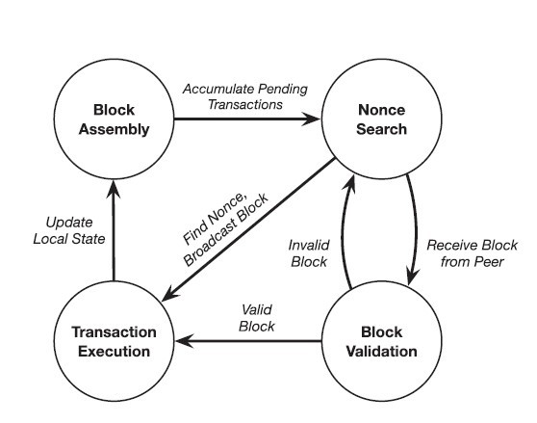
Figure 3: Proof-of-work consensus

Proof-of-work can be considered a repeated lottery that determines which miner is allowed to append the next block to the chain. All other miners validate and accept the new block before moving on to the next round of the consensus i.e., a new lottery. A miner’s odds of winning a lottery round (its degree of influence over the operation of the blockchain) are proportional to the rate at which it can test nonce values in search of a valid proof of work. Therefore, a miner’s influence is tied to its computing power. The tying influence of the result to the miner’s computing power also gives proof-of-work consensus resilience to Sybil attacks. A Sybil attack is a technique in which an adversary disguises themselves as many users of a system to gain control over the system.
The quantity t is a bit string that represents an upper bound on the output of the hash function on the cryptographic hash of the block’s contents, including the nonce used to produce the proof of work. This threshold is controlled by an adaptive and timevarying parameter known as the difficulty of the mining process. A smaller t value reduces the number of values that can serve as a valid proof of work, while a larger t value increases the number of such values, thus increasing the probability of finding a nonce. Therefore, mining difficulty can be defined as the expected number of values that must be tested before any of the network’s miners succeeds in finding a proof of work. It is adjusted to keep the expected time delay between two successfully mined blocks constant even as the collective computing power of a blockchain’s peer-to-peer network fluctuates over time as nodes join and leave the network. [1]

Forks
Proof-of-work consensus is analogous to a lottery system that is used to select the next block in the chain. Each new block is chosen non-deterministically and there can be situations where different miners find a nonce and append a block of transactions to the chain nearly the same time which leads to a split view of the blockchain’s state among the members of the network, known as a fork in the chain (see Figure 4).
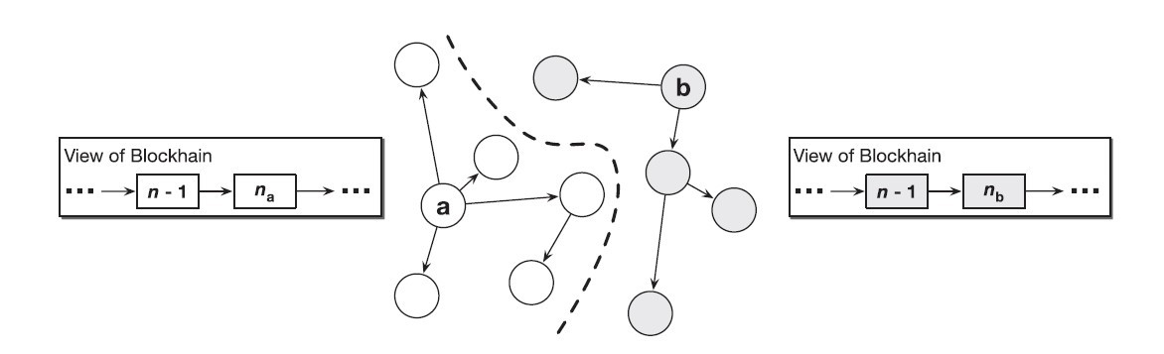
Figure 4: Fork in a blockchain

Consider for example two miners a and b in the blockchain network, and each is able to find a valid nonce that satisfies the proof-of-work consensus protocol nearly the same time. Both a and b broadcast the newly created block together with the nonce to the network. As the new blocks propagate through the blockchain’s peer-to-peer network, one group of nodes accept and append a’s block to their local copy while another group of nodes append b’s block to their local copy. The same is the case with miners as well, where there is one group of miners that accept the block created by a and a second group of miners that accept b’s block. The hashing power of the network is now split into two competing groups, thus making the network vulnerable to attacks.
This problem is resolved by adding a simple rule to the proof-of-work consensus protocol i.e., when a node observes a fork in the blockchain, it must always follow the longer of the two chains, i.e., the chain that contains a greater number of blocks. Every node should treat the longer fork as the canonical state of the chain, and every miner should append new blocks onto the head of this chain. One of the two forks will have its first block adopted by the group of nodes in the network with more hashing power. This subset of the network will then be able to mine and append new blocks at a faster rate than the nodes backing the fork with lesser hashing power. By the very fact, it will become longer over a period of time, and this disparity will only keep growing as more nodes identify the longer fork and abandon the shorter fork. Finally, it would be the longer fork that prevails.
The blockchain’s structure where each block contains a hash of its previous block, and the possibility of forks to occur has led to the concept of confirmations. When a transaction is included in what appears to be the newest block on the chain, it is not yet certain that this block will become part of the canonical chain, and therefore that the transaction will finally become a part of the network. There is a probability that a block turns out to be part of an eventually abandoned fork. Moreover, the more successors a block has in the chain, the more resistant those block’s transactions are to attack by adversaries. This is because an attacker must have the hashing power necessary to force the network to roll back all of a block’s successors before it can alter the contents of the block itself. Therefore, many blockchain applications will not consider a transaction immutable until a sufficient number of blocks have been appended as successors to the transaction’s block. Each successor reduces the probability that the transaction is manipulated by an attacker or discarded as part of an abandoned fork. [1]
2.2.3 Merkel Trees
A Merkle tree is a data structure which constitutes a hash tree where the root hash of a particular node (leaf nodes) is converged at by a sequence of hash operations along the path that converges that converges at the root node. This allows us to verify the authenticity of a particular transaction and that it has not been altered (see Figure 5). They help in building cryptographic accumulators which helps us verify whether given transaction belongs to a block in a blockchain.
Therefore, a Merkle tree can be defined as a binary tree in which the data is stored in the leaf nodes. More specifically, given a set X which contains n elements. Each of the elements 1, 2, …, n is assigned to the leaf nodes of the binary tree. Suppose a[i, j] denotes a node in the tree located at the ith level and jth position. Here, the level refers to the distance to the leaf nodes and it is evident that the leaf nodes are located at distance 0. The positions numbered starting from 0 within the level and are considered from the left-most position. For example, the leftmost node of level 1 in a tree a, is denoted by a[1, 0]. The nodes at a distance one or more from the leaf nodes are considered to be intermediate nodes and they are computed as the hash of their respective child nodes i.e., a[i+1, j] = H(a[i, 2j], a[i, 2j+1]). Given n leaves, time complexity for constructing the tree is O(n) and the time required for proving the membership of an element is O(log(n)).
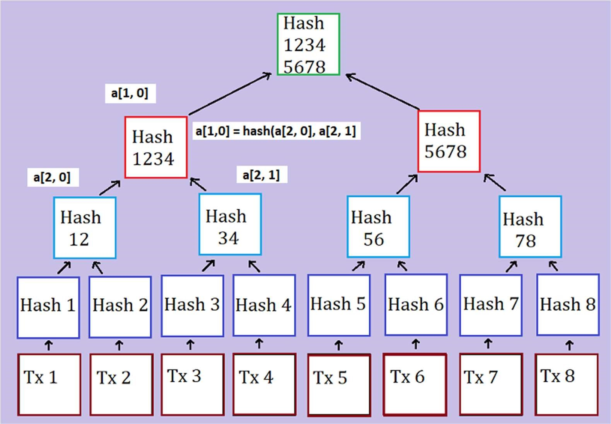
Figure 5: A Merkle tree of depth 3, accumulating transactions Tx 1 through Tx 8

The "hash" of a block is a hash function applied on the block header which contains roughly 200-byte piece of data which includes a timestamp, nonce, previous block hash and the root hash of a data structure called the Merkle tree storing all transactions in the block. In a Merkle tree, the intermediate nodes are the hash of its two children and a single root node which is also formed from the hash of its two children, representing the "top" of the tree. The purpose of the Merkle tree is to facilitate the verification of data in the leaf nodes by the using only the header of a block. Here, the hashes propagate upward, where if an adversary attempts to swap in a fake transaction into the bottom of a Merkle tree or alter its contents in any manner, this change will cause a change in the node above, all the way until the root of the tree and therefore the hash of the block, causing the protocol to register it as a completely different block. The altered block becomes invalid since the nonce value does not satisfy the hash function applied on the contents of the newly altered block. [18]
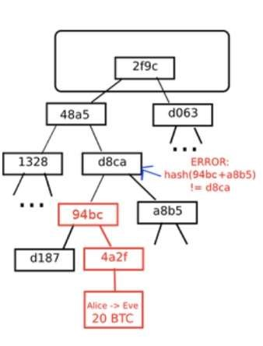
Figure 6: An attempt to change the Merkel Tree

2.3 Ethereum
Ethereum is a blockchain like bitcoin, but also has certain additional features that helps it extend its scope beyond just the management of cryptocurrencies. It shares many of the common elements such as a peer-to-peer network connecting participants, a Byzantine fault–tolerant consensus algorithm for synchronization, the use of cryptographic primitives such as digital signatures and hashes, and a digital currency (ether). Yet, the purpose of the design and construction of Ethereum is different from those of the open blockchains that preceded it, including the Bitcoin. Ethereum’s purpose is not primarily to be a digital currency payment network. While the digital currency ether is necessary for the successful operation of Ethereum as a blockchain, ether is only intended as a utility currency to pay for use of the resources on the Ethereum platform such as memory and computation.
Unlike Bitcoin, which has a very limited scripting language (a set of opcodes), Ethereum is designed to be a general-purpose programmable blockchain that runs a virtual machine capable of executing code of arbitrary and unbounded complexity. Bitcoin’s Script language is, intentionally, constrained to simple true/false evaluation of spending conditions. Whereas, Ethereum’s language is Turing complete (see section 2.3.3), meaning that Ethereum can function as a general-purpose computer that is able to execute complex code. The idea was that by using a general-purpose blockchain like Ethereum, one could develop applications on a blockchain without having to implement the underlying mechanisms of peer-to-peer networks, blockchains, consensus algorithms, etc. The Ethereum platform is designed to abstract the complex details of the blockchain and provide a secure programming platform for developing decentralized blockchain applications. Unlike the bitcoin that tracks only the state of currency ownership Ethereum tracks the state transitions of a generalpurpose data store. This store that can hold any data in the form of key–value pair. A key–value data store holds values required by a program, each referenced to by its corresponding key. For example, the value “04-09-1992” is referenced by the key “DoB”. It is similar to databases used by today’s modern applications which contain a set of records that are uniquely identified by a key value. Ethereum provides memory that stores both data and code (usually used to manipulate the state of the data), and it uses the Ethereum blockchain to track how the state of the memory changes over time. Like with a general-purpose computer, Ethereum can load code into its state machine and execute that code, storing the resulting state changes in its blockchain. This helps us code logic and constraints and store them on the block chain, which can be executed by members of the network. This set of data and executable code on the blockchain is referred to as a smart contract which is discussed in detail in the coming sections. [19]
2.3.1 Accounts in Ethereum
Similar to Unspent Transaction Output Model (UTXO) in Bitcoin, in Ethereum, the state is made up of objects called "accounts", with each account having a 20-byte address and state transitions being direct transfers of value and information between accounts. An Ethereum account contains four fields:
- The nonce, a counter used to make sure each transaction can only be processed once
- The account's current ether balance
- The account's contract code (optional)
- The account's storage (empty by default)
"Ether" is the crypto-fuel or cryptocurrency of Ethereum and is used to pay transaction fees. In general, there are two types of accounts in the Ethereum blockchain: externally owned accounts, controlled by private keys, and contract accounts, controlled by their contract code. An externally owned account has no code, and one can send messages from an externally owned account by creating and signing a transaction using their private key, where as in a contract account, every time the contract account receives a message its code activates, allowing it to read and write to internal storage and send other messages or create contracts in turn.
Contracts in Ethereum should not considered as something that is compiled and executed rather, they are more like "autonomous agents" that live inside of the Ethereum blockchain and run on the Ethereum virtual machine. A specific piece of code is executed when called by a message or transaction from either an externally owned account or a contract within the blockchain. The contracts have direct and full control over their own ether balance and their key-value store used to store persistent data usually required by the functionality implemented within their code. Thus, a contract is a decentralized and immutable piece of code together with data that can be used to implement a specific requirement. [18]

2.3.2 Messages and Transactions
The term "transaction" is used in Ethereum to refer to the signed data package that stores a message, to be sent from an externally owned account. It represents a message that ideally includes data and currency. The currency either constitutes of the amount transferred to the recipient or transaction costs. A transaction contains the following parts:
- A recipient address
- A signature used to identify the sender
- An amount in ether (transferred from the sender to the recipient)
- A data field (optional)
- A STARTGAS value, represents a limit on the number of computational steps a transaction can take
- A GASPRICE value, which is a fee the sender pays for each computational step and is usually measured in bytes.
The first three are standard fields usually present in any blockchain. The data field is null by default, but the virtual machine has an opcode which a contract can use to access the data. For example, if a contract is functioning as an on-blockchain betting service, then it may interpret the data being passed to it as containing two "fields", where the first field contains the value of an outcome and the second field is the value staked by the better. The contract reads these values from the message data and places them in the key-value data store.
The STARTGAS and GASPRICE fields are important for Ethereum's anti-denial of service model architecture. In order to prevent accidental or adversarial infinite loops and the resulting wastage of memory and computational resources, each transaction is required to set a limit on how many computational steps of code execution is allowed. The fundamental unit of computation is "gas". In Ethereum a computational step usually costs 1 gas, but some operations cost higher amounts of gas because they are more computationally expensive. There are situations where the amount of data stored as part of the state of the transaction is large and a fee of 5 gas is charged for every byte. The purpose is to discourage an adversary who is financially rational from consuming computation, bandwidth and storage on the blockchain network. Therefore, a transaction that consumes resources in the network must pay a gas fee which is proportional to the resources consumed. [18]

Messages
Contracts can send "messages" to other contracts. Messages in Ethereum refer to objects that contain data and value (in ether) which are passed between two accounts. A message is usually created when contracts interact with each other or by a transaction. A message contains the following fields:
- The sender of the message (implicit)
- The recipient’s address
- The amount of ether to be transferred
- A data field (optional)
- A STARTGAS value
We notice, a message is similar to a transaction, except that it is produced by a contract and not by an externally owned account, as is the case with transactions. A message is produced when a contract’s code executes the CALL opcode. Like with a transaction, a message thus leads to the recipient account (a contract account) running its code. Thus, contracts can be made to interact with other contracts in exactly the same way that externally owned accounts can.
The gas required when making a transaction is the total gas required by the network for the consumption of its resources, which even includes all sub-executions present within that transaction. For example, if an external actor A sends a transaction to B with 100 gas, and B consumes 60 gas before sending a message to C, and the internal execution of C consumes 30 gas before returning, then B can spend another 10 gas before running out of gas. [18]
2.3.3 Turing Completeness in Ethereum

The term ‘Turing complete’ refers to an English mathematician Alan Turing, who is considered the father of computer science. In 1936 he created a mathematical model of a computer consisting of a state machine that manipulates symbols by reading and writing them on sequential memory. Turing later provided a mathematical foundation to answer questions about universal computability, meaning whether all problems are solvable. He proved that there are classes of problems that are not computable. Specifically, he proved that the halting problem is not solvable. The Halting problem refers to the question of whether it is not possible, given an arbitrary program and its input, to ascertain whether the program will eventually stop running. Ethereum’s ability to execute a stored program in a state machine called the Ethereum Virtual Machine (EVM), while reading and writing data to memory makes it a Turingcomplete system and therefore a Universal Turing Machine. The EVM is able to compute any algorithm, given the limitations of finite memory and hence prone to the halting problem.
The innovation in Ethereum’s is that it combines the general-purpose computing architecture of a stored-program computer with a decentralized blockchain. It thus creates the so called ‘world computer’ that is distributed across all the nodes in the network. In Ethereum, programs run ‘everywhere’ i.e., in each node, yet maintain a common state or behaviour which is enforced by the consensus rules of the blockchain. However, Turing completeness is very dangerous, particularly in open access systems like public blockchains, because of the halting problem. For example, modern printers are Turing complete and can be given files to print that send them into a frozen state after which they cannot be used to perform other operations. The fact that Ethereum is Turing complete means that any program of any complexity can be computed by Ethereum. But that flexibility brings issues relating to security and resource management. An unresponsive printer can be restarted and continued to be used by the network. But the same is not possible with a public blockchain.

Implications
Turing proved that we cannot predict whether a program will terminate by analysing it on a computer. More specifically, we cannot predict the path of a program without running it. Turing-complete systems can run into ‘infinite loops’ and ultimately results in the usage of an enormous amount of resources. In Ethereum, this poses a challenge: a smart contract can be created such that it runs forever when an externally owned account or another contract in the blockchain attempts to invoke it. This kind of a situation is termed, a Denial of Service (DoS) attack. How does Ethereum constrain the utilization of resources by a smart contract if it cannot predict the resource usage in advance?
In order to prevent the DoS attack, Ethereum introduces a metering mechanism called gas. As the EVM executes a smart contract, it carefully accounts for every instruction (computation power, memory, etc.). Each instruction has a predetermined cost in units of gas. When a transaction triggers the execution of a smart contract, it must include an amount of gas that sets the upper limit of what can be consumed running the smart contract. The EVM will terminate execution if the amount of gas consumed by computation exceeds the gas available in the transaction. The gas to pay for computation on the Ethereum network is bought with ether which is sent along with a transaction. Any unused gas post the execution of the transaction is refunded back to the sender of the transaction.
2.4 QTUM blockchain
The Qtum blockchain is a UTXO based smart contract system with a proof-of-stake consensus model. It uses the best of both Bitcoin and Ethereum blockchains. It has adopted the UTXO model of bitcoin which is more secure and uses the Ethereum Virtual Machine as its platform for contract execution. Qtum uses an Account Abstraction Layer (AAL) which maps the UTXO-based model to an account-based structure that is present in the EVM and achieves interoperability. It implements an on-chain governance system based on the Decentralised Governance Protocol (DGP) that allows QTUM token holders to participate in the voting and negotiation of the upgrade and iteration of the blockchain network. It also introduces a way for other participants in the ecosystem, including developers, community member representatives, miners, and other multi-party participants to propose and vote for proposals. DGP manages the parameters responsible for the proper functioning of the blockchain network through smart contracts embedded within the genesis blocks.
Some of the problems that the Qtum blockchain addresses are:
- Different blockchain platforms that exist today are not compatible with each other.
For example, the Bitcoin ecosystem based on the UTXO (Unspent Transaction Output) model is not compatible with the Ethereum ecosystem based on the Account model, and the level of interoperability between these blockchains is not sufficient enough for businesses to adopt them.
- On-chain governance of critical technical parameters that affect the system is difficult to achieve. For most decentralized platforms, once the mainnet deployment is completed, upgrade and governance of the blockchain is a major problem. Updates to Ethereum involved hard forks which are not backward compatible.
- The Proof-of-Work consensus mechanism requires spending of large amount of energy for mining and incentives for miners. The security of the system is largely dependent on the hashing power of miners in the network, where there is a risk of centralization in mining computing power and thus the network faces the danger of a
‘51 percent’ attack. [21]
2.4.1 Account Abstraction Layer (AAL)
The EVM is stack-based with a 256-bit machine word. Smart contracts that run on Ethereum use this virtual machine for their execution. The EVM is designed for the blockchain of Ethereum and thus, assumes that all value transfers use an accountbased method. Qtum is based on the blockchain design of Bitcoin and uses the
UTXO-based model. To translate the UTXO-based model to an account-based interface for the EVM and decouple the value transfer layer from the contract execution layer, Qtum created the Account Abstraction Layer (AAL). This facilitates interoperability and platform independence.
Qtum developed mechanisms for conversion between smart contract operations and UTXO operations, and has designed and developed four new Bitcoin opcodes:
- OP_CREATE: create a smart contract
- OP_CALL: call smart contract (send QTUM to the contract)
- OP_SPEND: spend QTUM in smart contract
- OP_SENDER: allow an address other than contract caller to pay for Gas
OP_CREATE passes the contract bytecode to the virtual machine. OP_CALL sends data, gasPrice, gasLimit, VMversion and other key parameters required to run smart contracts through transaction scripts, and finally passes them to the virtual machine. During the block creation process, the validator’s script parses the contents in the transaction. In addition to making regular checks on transaction scripts, it also checks whether transactions contain the above-mentioned opcodes. Note that the abovementioned opcodes are relate to operations that use funds which are stored as UTXOs. When the mentioned opcodes are encountered, those transactions are set aside to be separately processed. The contract transactions are then processed by the EVM into a special “Expected Contract Transaction List” which is executed by validator nodes. These transactions are then run on the EVM, and the resulting output is converted into a spendable Qtum transactions that support the operations related to EVM execution. Relying on this design, the Qtum x86 virtual machine can run on the blockchain in parallel with the EVM (Ethereum Virtual Machine), without the need to significantly modify the underlying protocol and retaining good functional scalability. Thus, any virtual machine based on the account model can be adapted to run on the Qtum blockchain when required.
Qtum has also adopted the concept of Gas from Ethereum which is a metering mechanism to track and restrict the use of resources belonging to the network. Use of the Gas model can prevent endless loops caused by errors and malicious attacks. They also encourage contract designers and users to make reasonable use of on-chain resources. Normally the address of the contract call sender pays the Gas, but the OP_SENDER opcode allows a third-party address, such as a distributed application service provider, to pay the Gas. As in Ethereum blockchain, there is also a state rollback for an ‘out of Gas’ scenario and a refund of remaining Gas after successful execution. [20]
2.4.2 Proof-of-Stake Algorithm
Proof of stake (PoS) is another type of consensus algorithm by which a cryptocurrency blockchain network aims to achieve distributed consensus. In PoSbased cryptocurrencies, the creator of the next block is chosen using various combinations of random selection and wealth or age. Here wealth and age refer to the stake of the validator who is responsible for the block creation and receives the transaction fees. A validator is the one who proposes the next block to be appended to the blockchain. The chance of a validator being selected is proportional to the total amount they have staked. In contrast, the algorithm of proof-of-work based blockchains such as bitcoin uses mining that comprises of solving computationally intensive puzzles to validate transactions and create new blocks.
Proof of stake must have a way of defining the next valid block in any blockchain. Selection by account balance would result in centralization, as the single richest member would have a permanent advantage. Instead, several different methods of selection have been devised. Certain blockchains that implement Proof-of-Stake algorithm use randomization to predict the validator of the next block, by using a formula that looks for the lowest hash value in combination with the size of the stake. Since the stakes are public, each node can predict with reasonable accuracy which account will next win the right to forge a block. [22]

Coin Aging
Some blockchains use a proof-of-stake system that combines randomization with the concept of ‘coin age’, a number derived from the product of the number of coins multiplied by the number of days the coins have been held by a validator. Older and larger sets of coins have a greater probability of signing the next block. For example, coins that have been unspent for at least 30 days begin competing for the next block. Once a stake of coins has been used to sign a block, its age is reset to zero and thus waits for at least 30 more days before signing another block. Also, the probability of finding the next block reaches a maximum after 90 days in order to prevent very old and very large collections of stakes from attaining a monopoly in the proof-of-stake consensus mechanism.
2.5 Smart Contracts and DApps
Until now, we have understood the concept of blockchain, different blockchains such as Bitcoin and Ethereum, Turing complete blockchains that run as Universal Turing
Machines (UTM), which can execute code of unbounded complexity. The purpose of Turing complete blockchains is to execute immutable code (or programs) that run deterministically. This concept of immutable programs that execute in a deterministic fashion, facilitated by a Turing complete blockchain is referred to as a smart contract. A decentralized application or a DApp is more complex and is composed of at least two components namely, a smart contract on a blockchain and a web user interface that interacts with the contract. A DApp may also include other components such as, a decentralized storage protocol such as InterPlanetary File System (IPFS) and a decentralized messaging protocol (for example, whisper is a peer-to-peer messaging protocol).
2.5.1 Contract Components
Smart contracts are written in a high-level language such as solidity. There are different components in a contract that have to be properly understood in order to efficiently design, develop, deploy and call a contract. We have used solidity to develop smart contracts for the Ethereum blockchain. The different components in a smart contract are as follows:

• Contract Bytecode
Once the contract has been written they are compiled to get the bytecode. This contains a set of instructions that are to be executed by the Ethereum Virtual Machine (EVM). They are not human readable and is understood and used by the EVM.

• Contract Address
Once compiled, the bytecode is deployed on the Ethereum (or any other blockchain) network using a contract creation transaction. The newly created contract is identified by an Ethereum address, an outcome of the creation transaction. The address can be used in a transaction as a recipient in order to send funds to the transaction or to call one of its functions.

• Application Binary Interface (ABI)
An ABI is an interface between two program modules and defines how data and functions within the smart contract (bytecode) are accessed. It is the primary way to encode and decode data present as machine code on the blockchain. Ethereum uses an ABI to encode contract calls and read data from the contract by defining functions that can be invoked and their arguments. More specifically, an ABI is specified as a JSON array of data and functions defined within the contract.

• Contract State
The state of the contract refers to the data stored within the contract, is changed by the execution of transactions. It is only when the transaction executes successfully that the transactions are recorded globally. If an execution fails because of an error all of the changes made to the state is ‘rolled back’. A failed execution is still recorded on the blockchain as an attempt.
2.5.2 Contract Development
Solidity is the high-level programming language we will use to develop smart contracts and understand their working. Solc is the compiler that converts high-level code written in Solidity to EVM bytecode. We will use a web-based development environment called Remix IDE for implementing smart contracts.
Let us consider a simple contract ‘LateFlightReimbursement.sol’ that makes payment for claims made, when flights are delayed.
pragma solidity ^0.4.25; contract LateFlightReimbursement{ uint256 public scheduledDepartureTime; uint256 public actualDepartureTime; bool public flag; address owner; address insured; uint256 public ownerBalance; constructor(address wallet) public payable { flag=false; owner=msg.sender; ownerBalance=owner.balance; insured=wallet;
}
function setScheduledDepartureTime(uint256 _scheduledDepartureTime) public { scheduledDepartureTime=_scheduledDepartureTime;
}
function setActualDepartureTime(uint256 _actualDepartureTime) public payable{ actualDepartureTime=_actualDepartureTime; if(actualDepartureTime>scheduledDepartureTime){ insured.transfer(msg.value); flag=true;
ownerBalance=owner.balance;
} else flag = false;
}}

In the above example we observe that a smart contract is defined in solidity using the ‘contract’ keyword. The contract consists of persistent variables (each of which consume space in the blockchain), a constructor that initializes the variables and functions. A function should be annotated with the ‘payable’ keyword, in order that it may collect or receive funds in ether. The above contract accepts an ‘address’ value that represents the insured’s wallet, which is defined in its constructor. It contains functions of setting the values of ‘scheduled departure time’ and ‘actual departure time’. When the value of ‘actual departure time’ is greater than ‘scheduled departure time’ the function setActualDepartureTime() transfers ether to the insured’s wallet using the transfer() method. The different data types used in the contract are uint 256 represents unsigned int, bool defines a Boolean value and address data type is used to store and Ethereum address.
2.5.3 Contract Deployment
Before a contract is deployed, it must be compiled using a solidity compiler. We use ‘solc’ to compile solidity code and get the ABI and bytecode that are important components used to deploy and call the contract. Bytecode is the machine code that is deployed in the EVM and the ABI, which represents the structure of the contract is used to access the contract deployed in the blockchain.
The ABI for the above-mentioned contract is of the form –
[
{ "constant": false, "inputs": [{"name": "_actualDepartureTime", "type":
"uint256"}], "name": "setActualDepartureTime", "outputs": [], "payable": true,
"stateMutability": "payable", "type": "function"},
………, {"constant": true, "inputs": [], "name": "scheduledDepartureTime",
"outputs": [{"name": "", "type": "uint256"}], "payable": false, "stateMutability":
"view", "type": "function"}
]
Once compiled, the code is deployed onto the blockchain. In our case we have compiled and deployed the contract using Remix IDE (see figure 7). When the contract is deployed a transaction is executed on the blockchain, and a contract is created. The contract represents an account that is identified using an address obtained as the result of the contract creation transaction. After deployment, the components used to access the contract are the contract address and the ABI. An example contract address is ‘0xd4fe68a6aBC4e8BD59b9fB15f13c2A40cD883EE6’

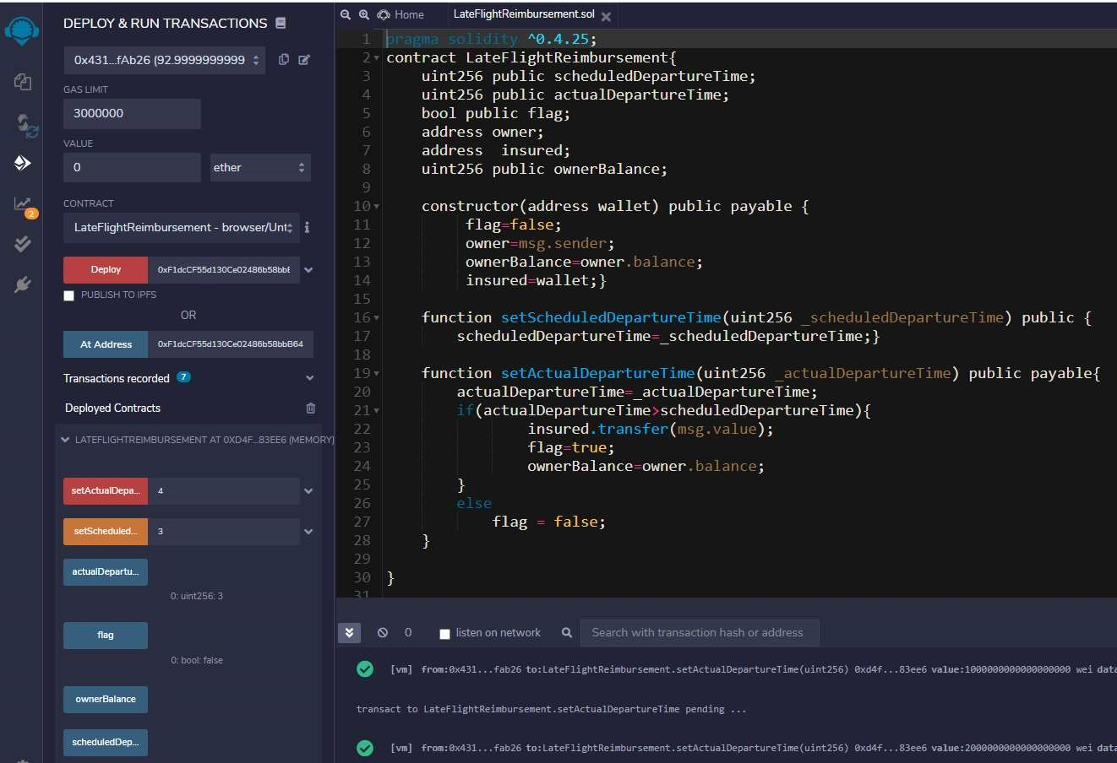
Figure 7: Deploying a contract using Remix IDE

Chapter 3

Oracles in Blockchain
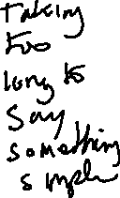
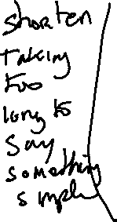
In the previous section we considered an example smart contract, which contained functions that could be called from an externally owned account (EOA) to alter the state of the contract. The real-world use cases of smart contracts essentially have monetary value attached to them and vulnerabilities in the system can be exploited for financial gain. It is important that calls made to the contract, and data triggering certain actions such as transfer of funds within the contract is verified. Otherwise, an adversary could send incorrect data to the contract, resulting in the execution of code that is favourable to him/her. It can also happen that data is not made available to the smart contract when required and contract execution is stalled. So, it is critical that correct data is made available to contracts on the blockchain and at the right time. This piece of work is critical to the working of smart contracts and is implemented using an Oracle.
3.1 Introduction to Oracles
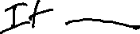
An Oracle is essentially a system that answers a question that is external to the blockchain. It acts as a bridge that connects blockchains and the outside world. An oracle system consists of off-chain and on-chain components, where off-chain components are responsible for collecting the data in a secure fashion and on-chain components comprise of oracle’s contracts that are used to send data to the contract that has requested for the oracle’s service. They send extrinsic information to contracts on the blockchain by executing transactions that contain the data payload. However, such data simply cannot be trusted and used to execute high value contracts. It is important to create a trustworthy model of an oracle, so that they are acceptable by businesses to execute their use cases.
All oracles in general, contain a few critical functions by definition, which include the following –
- Collect data from a source external to the blockchain.
- Transfer that data on-chain together with signature.
- Data is made available to a smart contract’s storage.
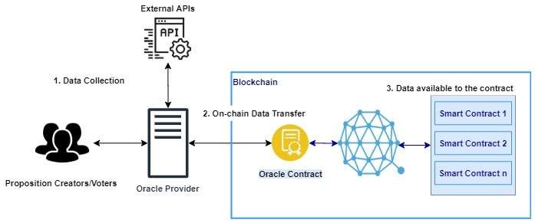
Figure 8: An Oracle System in general

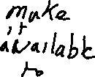

It is important to note that oracles are not data sources, but a middleware that queries, verifies and authenticates data sources external to the blockchain and then passes the information to the smart contract on the blockchain that requested the information. Another key advantage of using an oracle is that it provides for off-chain computation. Computation and usage of resources on the blockchain is costly, and an oracle can be used to perform large computations outside the network, with only the result being returned for use to the blockchain. There are many oracles that differ in their design and functionalities, currently in the market. How an oracle functions is dependent on the use case or purpose it is designed for.

Oracle Design Patterns
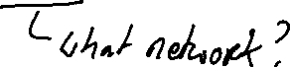
An oracle can be set-up in 3 three different known designs namely - immediate-read, publish-subscribe, and request–response. Oracles having immediate-read design is implemented in situations where data is required to make an immediate decision. For example, ‘Is a person above 18 years of age?’. This type of an oracle stores data only once (which may be updated later) and other contracts on the blockchain that require that information can access it using a request call. Publish-subscribe setup is where an oracle broadcasts data to the network and those who have subscribed listen to the broadcasted data.
The request-response model is used when the data space required is too huge to be made available in a smart contract and users need only a small portion of the data for computation at a time. When an externally owned account interacts with a contract in the blockchain that uses the oracle, it results in an interaction with the oracle’s contract which is essentially a request to the oracle, with the associated arguments detailing the data requested. The oracle then interacts with its contract to fetch the query and the different parameter, which is used to perform the actual query of the off-chain data source. The result of the query is signed by the oracle owner and delivered in a transaction to the contract that made the request, either directly or via the oracle’s contract. [19]
Although blockchains can be setup in three different ways, oracles are fundamentally classified as centralized and decentralized. A centralized oracle is controlled by a single entity, whereas a decentralized oracle is a system where data is collected from several sources and controlled by one or more entities that are equally privileged. (See sections 3.2 and 3.3)
3.2 Centralized Oracles
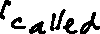
A centralized oracle is governed by a single entity, which is the only provider of information for the smart contract. Having only one interface can be very risky, in the sense, a reliability of a contract that is secure on the blockchain is entirely dependent on the entity controlling the oracle. A bad actor can manipulate the data being sent from the oracle to the on-chain contract, which will have a direct impact on the smart contract. Thus, the main problem that exists with centralized oracles is of a single point of failure, which makes the contracts vulnerable to attacks. Contracts of higher value act as incentives for bad actors to attack the oracle system. One of the most widely used centralized oracle is Provable.

3.2.1 Provable (previously Oraclize)
Provable [6] is the leading oracle provider in the blockchain industry, fulfilling thousands of requests every day on various platforms such as Ethereum, Hyperledger and R3 Corda. As explained already, an oracle is an intermediary service that is introduced as a result of blockchain contracts not having the ability to make request to external services that provide data which is critical to their functioning. But, to rely on an intermediary system, would be to betray the reduced-trust and security model of the blockchain. Therefore, it is important that a reliable and trustworthy model which does not comprise the security provided by the blockchain.
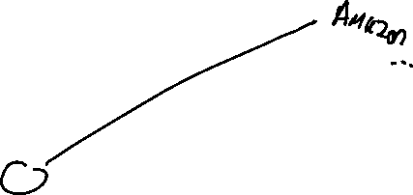
Provable follows a request-response model where a request is made by a relying contract to the oracle’s contract and a response containing the required data is returned. It has developed a trust model which demonstrates that the data fetched from a source is not altered and is genuine. For this purpose, it sends data to the contract in the blockchain, together with an authenticity proof. Authenticity proofs are cryptographic guarantees that the data has not been tampered with. Provable uses TLSNotary [27] proofs that allow it to provide an evidence that HTTPS web traffic occurred between the client and the server (data source provided by the contract). TLSNotary allows an auditee (client) to make a https request to a web server such that the auditor is able to verify the response before the client can access them, by temporarily withholding some information required to view the response. The provable service uses the AWS machine instance as the auditor which attests to that the data received is the result of the client’s interaction with the specified data source.
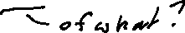
The outcome is a TLSNotary secret, which is stored safely in the instance and is used to provide honesty proofs.
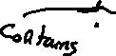
A valid request from a smart contract to the provable service is of the format –
- A data source, such as a URL to an API
- A query
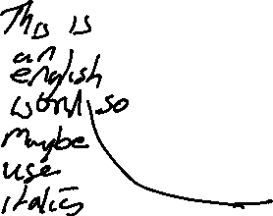
- An authenticity proof (optional)

1) Data Source
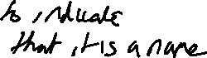
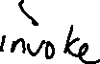
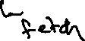

It refers to a data source that the contract delegates as its trusted source. E.g., nasdaq.com. Provable currently offer services for data sources such as a URL, Wolfram Alpha, IPFS, Random and Computation. AURL can be an API or a web page. Wolfram Alpha is a computational engine that can be specified as a data source in the provable query to retrieve an answer to the query string provided. Random is used to generate an untampered random value.

2) Query
A query is an array of parameters, which is used by the oraclize service to process the request. For example, in the case of the data source being specified as ‘Wolfram Alpha’, the query parameter can be ‘Flip a coin’ which generates a random value which is either a ‘heads’ or a ‘tails’.

3) Authenticity Proofs
Authenticity proof form a critical part of trust model of Provable. They refer to the type of authenticity proofs required to prove that the data supplied has not been tampered with. E.g., TLSNotary and proof storage IPFS .
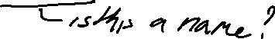
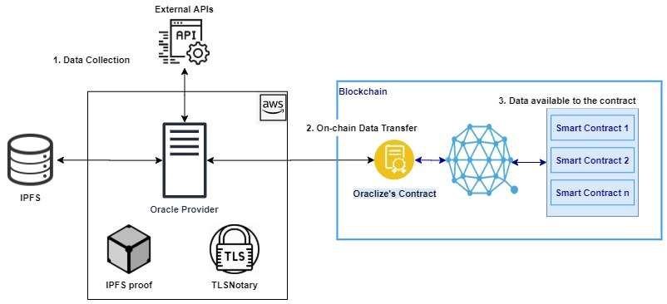
Figure 9: Oraclize - A Centralized Oracle System

Working
Let us now consider a working example of the Provable service, where we call the
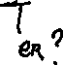
WolframAlpha computing engine which returns the result for a random experiment of ‘tossing a coin’. The contract transfers its funds to the bettor, if the outcome he has staked matches the result of the random experiment.
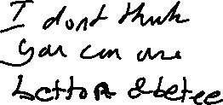
Code:
pragma solidity ^0.4.25;

import "github.com/provable-things/ethereum-api/provableAPI_0.4.25.sol"; contract ExampleContract is usingProvable { address bettor; string result;

function Constructor(address _bettor, string _result) public payable{ bettor=_bettor; result=_result;
}

function __callback(bytes32 myid, string _result) public{ if (keccak256(abi.encodePacked(result)) == keccak256(abi.encodePacked(_result))) { bettor.transfer(address(this).balance);
}
}

function updatePrice() payable public{
provable_query(60, "WolframAlpha", "flip a coin");
}
}
The above contract uses the provable service by inheriting the usingProvable class.
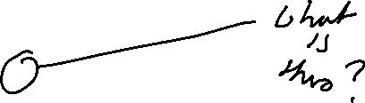
The provable query is present in the function updatePrice(), which queries the WolframAlpha computing engine with the phrase ‘flip a coin’. The provable contract stores the query, the data source and the scheduled time mentioned within the provable_query() function. E.g., 60, "WolframAlpha" and "flip a coin". The operator in charge of the provable service checks the provable contract for data requests made by contracts using the provable service, by calling functions that access the state of the contract, from an externally owned account (EOA). Provable maintains a centralized server to access the query requests on the blockchain and relay them to their respective data sources, in our case ‘WolframAlpha’. The response is returned by the server to the provable contract (on-chain), which then passes the response to the relying contract using a __callback() function. Provable uses the __callback() function defined in the contract to pass in the response to the contract. Given below is a figure that depicts the request flows of a smart contract that uses the Provable service.
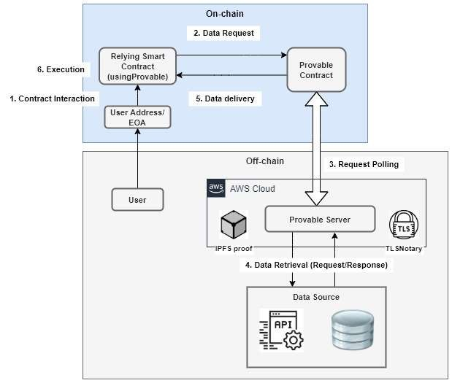
Figure 10: Request flows in Provable

3.2.2 Town Crier
Another centralized oracle system is the Town Crier. Unlike Provable that uses authentication proofs, Town Crier [8] uses a trusted execution environment to guarantee that the data received from the source is not tampered with. It provides an authenticated data feed for smart contracts on the Ethereum blockchain, by creating a secure channel between the https-enabled data source and the relying contract. It requests data from a website and send it to the relying contract in the form of datagrams. It uses Intel Software Guard Extensions (SGX), a trusted hardware capability to execute the core functionality in an SGX enclave. The enclave protects the code which constitutes of the core functionality against malicious processes by defining private regions of memory. It also able to provide attestations or proofs to remote clients of their interaction with a secure SGX-backed instance of Town Crier code.

The three main components of Town Crier are the Town Crier contract, the Enclave and the Relay (See figure 10). The Town Crier contract resides on the blockchain, whereas the Enclave and the Relay is present within a centralized server managed by Town Crier. The contract on the blockchain that uses Town Crier’s services is referred to as the relying contract or requester. The data source is a website or a server that Town Crier communicates with, over a secure https channel.

Town Crier Contract (TC contract)

It is a smart contract which acts as an interface between the relying contract and the data source. It is designed to provide a simple API to relying contracts on the blockchain, for its requests to the Town Crier service. The TC contract accepts datagram requests from relying contracts in the blockchain and returns the response (datagrams) provided by the Town Crier service. The TC contract account is responsible for managing the funds of the oracle system.

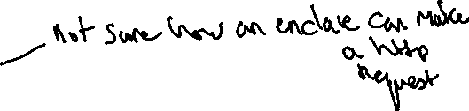
Enclave
The Enclave is the trusted execution environment where the core code that implements the functionality of Town Crier is run. It ingests and fulfils the requests forwarded by the TC contract. It fulfils requests by querying external data sources through secure https communication and returning the datagram as a digitally signed blockchain message. The Enclave guarantees security by running code in complete isolation from all the external processes, even the host operating system.

Relay
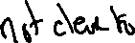
The Relay in Town Crier is a system that enables communication between the Enclave and external data sources such as a website or an API. It serves as a bridge between the Enclave and the external entities such as the blockchain, data sources and clients. It polls the blockchain to monitor the state of the TC contract. A web server is run by the Relay to serve off-chain requests from clients such as requests for attestations. An attestation provides a public key which can be used to verify whether the right code is being executed by the Enclave. Finally, the Relay also manages the traffic between the Enclave and external data sources.
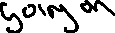

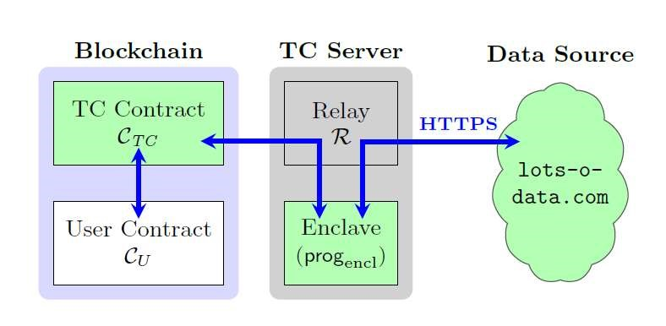
Figure 11: Town Crier Architecture

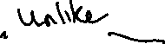
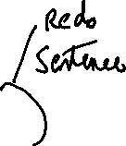
3.3 Decentralized Oracles
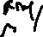
Different from centralized oracles, there is a subclass of blockchain oracles that follow a permissionless and equi-privileged mechanism of reporting external data required by the contract, called decentralized oracles. Here, users may participate as reporters at their own will, and all participants have identical privileges (i.e., without bias). A decentralized oracle model fundamentally consists of an oracle operator, proposition creators, voters and a consensus mechanism. [5]

Oracle Operator
To achieve decentralization the consensus operation of the oracle system is implemented on a decentralized platform, such as Ethereum or Hyperledger. This entity is referred to as the operator, which maintains a list of created propositions and their votes, required to decide on the correct outcome. A user may submit new propositions to the operator, after which several users vote on an active proposition. After a certain duration the active propositions are closed the votes are no longer accepted from users. The total votes are then counted, and the rewards distributed by the operator.

Proposition Creators
Proposition creators are those entities that are concerned with the right data being provided to the smart contract on the blockchain. They choose propositions that are to be included in the oracle system, by allocating funds for the subsequent effort of transferring correct data on to the blockchain.

Voters
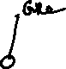
A decentralized oracle takes inputs from users (either humans or other data sources such as an API). These users who inputs data into an oracle is referred to as a voter and any number of voters could join the system to provide their inputs. Suppose V = {v1, v2, v3, ..., vn} be the set of all voters who participate in the decentralized oracle protocol. For a proposition pj , each voter vi ∈ V supports an outcome Oij. Voters who collude to support a false outcome are considered adversaries and those that vote the same outcome for each and every proposition are considered lazy voters.

Consensus Mechanism
A proposition is randomly selected and assigned to all voters, who vote for a particular outcome. Finally, when the proposition is closed, all the votes and outcomes are tallied to find the outcome that has majority of the votes. The outcome with the majority of votes is reported as the correct outcome by the oracle.
Some of the decentralized oracle platforms that exist today are Astrea, Augur, Chainlink and Gnosis. All the aforementioned oracles essentially include the components – an operator, proposition creator, voters and a consensus mechanism as described previously. They differ from each other, in the steps taken by them to achieve consensus, authentication (proofs) and nash equilibrium. Nash equilibrium is a concept of game theory where no player gains when deviating from their initial strategy. [25] Each of these oracles have different trust models and each trust model is suited for different businesses or use cases. Let us now consider the design and working of various decentralized oracle.
3.3.1 Astrea
Astrea [28] is a decentralized oracle service that implements a voting-based consensus mechanism to arrive at the truth and falsity of propositions. Players of the game fall into two categories: voters and certifiers. Certifiers play a high-stakes game and voters have lesser to stake. The rewards of the game is proportional to the risk (stake) involved in the game. Parameters of the game is set such that Nash equilibrium is maintained and ensuring all rational players behave honestly. Users of Astrea take part assuming one of the following roles: submitters, voters and certifiers.

Submitters
Submitters add propositions to the oracle system together with a bounty, which is later distributed to all the users who were responsible for providing the correct outcome for the propositions. They are usually entities that require critical information or data, in order to trigger certain functions within their smart contracts.

Voters
They are players who have roles that accompany low-risk and low-rewards. They do not have to deposit large stakes in order to cast their vote, which is not the case with certifiers. Albeit the oracle system requires a stake to be deposited even before the voters are notified of the proposition they will be voting on. A proposition is chosen in random and is provided to the voter who has staked a deposit. The sum of votes weighted by their corresponding deposits, determines the result of the voting process.
There is also a limit set on the maximum deposit a voter can stake.
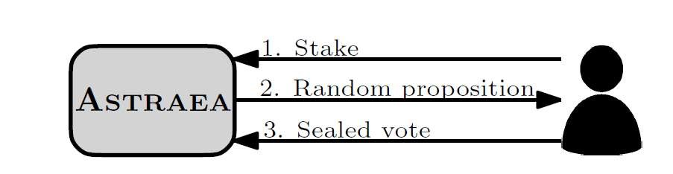
Figure 12: Voting in Astrea

Certifiers
Certifiers play a game of high risk and high rewards. Unlike voters, they get to choose a proposition from a list of propositions, by placing a large deposit to certify it as either true or false. The outcome of the process for a proposition is the sum of its certifications weighted by their deposits. The deposit size of certification is a parameter that is set to be large enough, that certifying may involve substantial risk. Not all propositions have certifications and the oracle does not compel submitters to include them either.
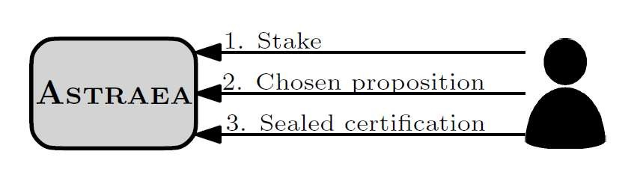
Figure 13: Certifying in Astrea

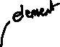
Working of Astrea
An entity critical to the working of Astrea is the proposition list P, which contains a set of propositions. Each proposition in the list is denoted by pi ∈ P and has a truth value ti, which is associated with a bounty Bi. The system also maintains two certifier reward pools RT and RF that contain rewards to be distributed to certifiers belonging to the winner universe. The purpose of using two separate reward pools is to prevent a corrupt co-ordinated strategy where both voters and certifiers support a constant outcome true or false, in order to maximize their gains without expending any effort.
The different variables used by the oracle system are – si, j, b denotes the amount staked by a player i on voting for proposition pj and b is either true or false (T/F), smax and σmin are parameters that denote maximum voting stake and minimum certifying stake respectively. When voting, users stake a deposit that is less than the value of smax i.e., si, r, v <= smax on a vote for proposition pr , where r is not yet known to the voter. The value of r is chosen at random from the list of propositions. Users certify a proposition by submitting a stake σi, j, c >= σmin, where c denotes a sealed certification c ∈ {T, F} for proposition pj. At a certain time, when the proposition pj has accumulated sufficient voting stake, it is decided and values sTOT, j, T , sTOT, j, F, σTOT, j, T and σTOT, j, F are calculated. For b ∈ {T, F}, the values are computed as follows:
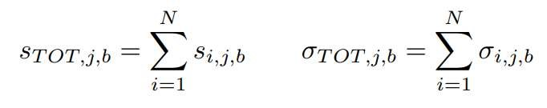
Once the values are computed, the voting and certifying outcomes are determined using the following logic.
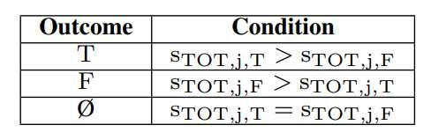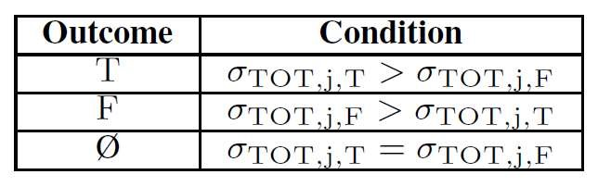
Table 1: Voting and Certifying Outcomes

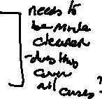
We observe in Table 1 that a simple majority determines the outcome. Alternatively the oracle system may also require a higher majority instead of a simple majority for true and false outcomes and otherwise remain undecided (Ø). The game has 3 possible outcomes – true, false and unknown/undecided. The outcomes of propositions are used in the distribution of rewards and penalties. The suggested oracle output for a proposition pj follows the voting outcome if it matches the certification outcome or the certification outcome is undecided. The oracle does not necessarily have to output a value which is either 0 or 1, but it can also output a value in the range [0, 1] which denotes the level of confidence in the truth or falsity of the proposition pj.

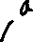
Rewards and Penalties
In case of an outcome which is either true or false, player’s vote reward for a proposition pj is the proportion of their stake times the bounty submitted for pj. The penalty given is the amount staked for an outcome that does not correspond to the oracle’s final outcome. When the outcome is undecided (Ø), voters are not penalized whereas certifiers are penalized. The rationale behind penalizing certifiers and not voters is that certifiers get to choose their propositions, while voters are given one at random. The rewards and penalties for proposition pj are shown in table 2 below.
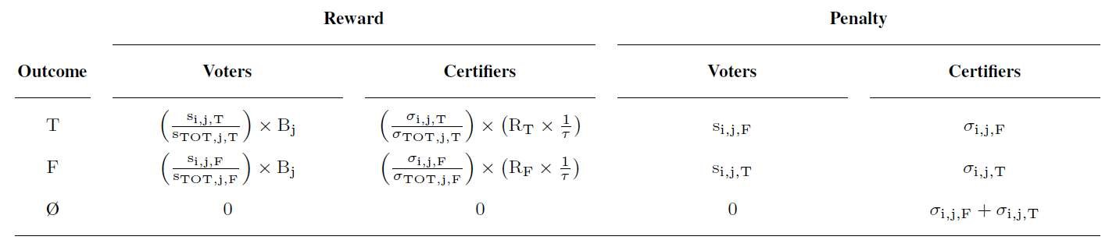
Table 2: Summary of Rewards and Penalties
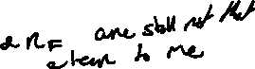

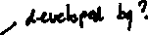
3.3.2 Chainlink
Chainlink is another decentralized oracle whose architecture basically consists of two sets of components – on-chain and off-chain components. The on-chain component makes requests on behalf of a user contract, which is also a smart contract that bridges the requesting contract with the off-chain data source. Besides being an interface, the on-chain component also implements consensus mechanisms required by a decentralized oracle system. The off-chain component consists of a network of oracles nodes that connect to the blockchain network. They harvest responses to the requests made off-chain, which is relayed to the on-chain component that aggregates them into a single response before being sent to the relying contract. Let us now discuss the architecture in detail.

On-chain Architecture
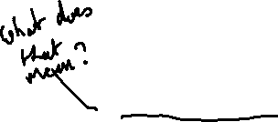
The on-chain component of Chainlink [28] comprises of three contracts: a reputation contract, an order-matching contract and an aggregating contract. The reputation contract keeps track of the performance of oracle nodes that perform off-chain requests on behalf of the on-chain contract. The order-matching contract collects a service level agreement (SLA), logs their parameters, and collects bids from the oracle nodes (data providers). It then uses the data present in the reputation contract to select bids that best matches the SLA. The aggregating contract collects the responses from oracle providers and outputs the final result of the Chainlink query. It also forwards a feedback of oracle providers to the reputation contract, which is used later for bid selection. The on-chain workflow has three stages: oracle selection, data reporting and result aggregation.

1) Oracle Selection
The relying contract that purchases services from the oracle specifies requirements that constitute the SLA proposal. The proposal has details such as query parameters and the number of oracles needed by the purchaser. It also specifies the reputation and aggregating contracts to be used by the agreement. Using logs that are maintained onchain, purchasers are able to view, filter and select oracle providers based on their reputation, via an off-chain interface.
Once the purchaser submits the SLA, it is forwarded to the order-matching contract. This triggers a log that oracle providers can use to view, filter and select currently available SLAs based on their capabilities. Oracle service providers (ChainLink nodes) view the SLAs and bid on an order. They commit to an order by attaching a penalty amount that would be lost if they did not stick to the conditions laid down in the SLA. The bidding window is closed when sufficient number of qualified bids have been received. The requested number of oracles is then selected from the pool of bids. And, penalty payments of oracles that were not selected are returned to oracle providers (or nodes).

2) Data Reporting
The off-chain oracle providers execute the requests using the parameters mentioned in the SLA and relay the response results of the request to the oracle contract on-chain.

3) Result Aggregation
After the oracle providers have relayed their results to the oracle’s on-chain contract, they are in turn fed to the aggregating contract. The aggregating contract collects results to output a weighted answer, which is sent to the requesting contract. Also, validity of the data provided by each off-chain oracle is forwarded to the reputation contract. Chainlink also allows purchasers to use customized contracts for aggregation, provided they follow the required standards.

Off-chain Architecture
Off-chain components consists of a network of oracle nodes that connect to the blockchain. They make requests on behalf of the requesting contracts and forward the results on-chain. The Chainlink oracle nodes run a standard open source core implementation capable of handling standard blockchain interactions and making requests to external resources such as an API or a database. Node operators may also choose to add custom code via software extensions called external adapters. Let us now discuss each of them in detail.

1) Chainlink Core
The core node-software of Chainlink, equips the oracle providers (nodes) with functionality required to interact with the blockchain, schedule and balance workload across its services. The work performed by the nodes is divided into sub-tasks and is processed as a pipeline to reach a final result. The core node-software comes with built-in subtasks such as making http requests, JSON parsing, and conversion of data to blockchain formats.

2) External Adapters
Custom sub-tasks can be defined by node operators by creating adapters. External adapters refer to services provided by a simple API. A complex interaction with multi-step APIs can be divided into simpler sub-tasks with parameters, using adapters.

3) Subtask Schema
With different developers maintaining varied types of adapters, it is important that they follow some type of standard to ensure compatibility. Chainlink implements a JSON schema which specifies what inputs an adapter needs and how they need to be formatted. In addition, adapters also specify a schema that describes the output format of each subtask.
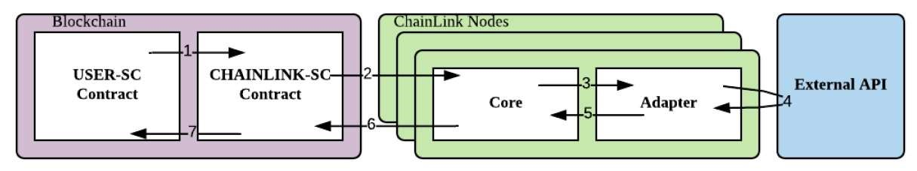
Figure 14: Workflow of Chainlink

Request Workflow

When a relying contract ‘USER-SC’ makes an on-chain request, it is forwarded to CHAINLINK-SC which logs an event, which is then viewed by oracle providers. The core code present on the oracle nodes retrieves those events and forwards them to the adaper. ChainLink adapter makes a request to an external API using the parameters specified in event forwarded by the adapter. ChainLink adapter then processes the response and sends it back to the core, which relays the data to the on-chain oracle contract ‘CHAINLINK-SC’. The responses provided by the oracle nodes are combined into a single response and sent to USER-SC.

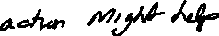
Decentralization in Chainlink
Chainlink creates a trust model by following three approaches – distribution of data sources, distribution of oracles and use of trusted hardware. The oracle achieves decentralization by including several data sources and oracle providers.

1) Distribution of Data Sources
A single data source makes the oracle service less reliable and becomes a single point of failure. The solution to a single faulty data source is to collect data from multiple sources and aggregate them into a single response. An oracle provider may query a collection of data source s1, s2, …, sk to obtain responses r1, r2, … rk and aggregate them into a single answer ‘A’. Aggregation can be done by checking if the majority of sources return an identical value for a particular request. The function which aggregates the responses, could be modified to make the system robust against erroneous data. For example, calculating the mean after discarding outliers.

2) Distribution of Oracles
As the use of several data sources increase the robustness of the oracle system, so does the concept of distribution of oracles. Instead of using a single oracle to report to the oracle contract on-chain, the purchaser can require a set of oracles to collect data from an external source and pass them to the blockchain. Each oracle contacts its own set of data sources, which may or may not overlap with those of other oracles. The responses returned by all the oracles are aggregated into a single authoritative value by the oracle’s aggregating contract, which is present on the blockchain.
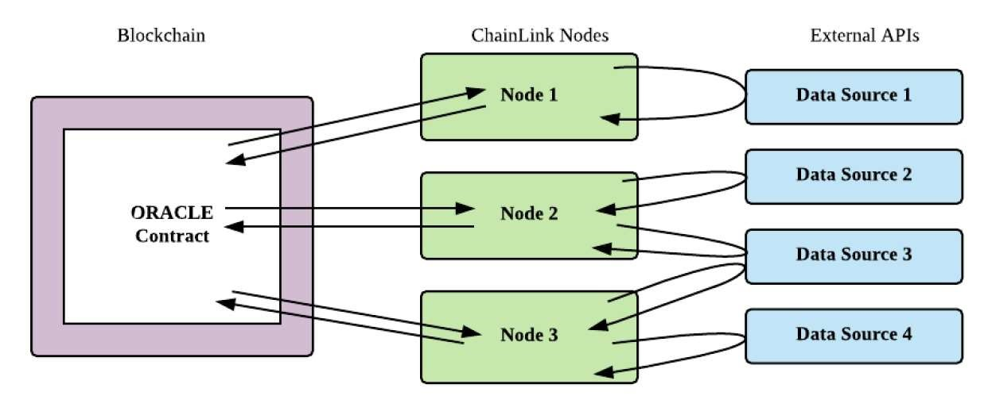
Figure 15: Request Distribution (among oracles and data sources)

Reputation System
As discussed, the reputation contract stores details related to the performance of each oracle. Purchasers of the oracle system are able to view the performance metrics of oracle providers and take a well-informed decision. The reputation system essentially monitors the oracles for availability and correctness. It records the failures of an oracle to respond to the request in a timely manner and incorrect responses measured by deviations in responses from those of its peers. The reputation system logs the following metrics: total number of assigned requests, total number of completed requests, total number of accepted requests, average time to respond and amount of penalty payments. It incentivizes oracle providers to behave correctly and also ensure high availability. Both negative user feedback and penalties significantly affect the brand value of the oracle system. Thus, it creates a mechanism where wellfunctioning oracles secure good ratings and consequently chosen by several relying smart contracts to be their data provider.
3.3 Augur

Augur [29] is a decentralized oracle and prediction market platform where individuals speculate the outcome of certain events. The participants who predict the outcome correctly earn rewards while others lose them. An Augur market is resolved in four stages: creation, trading, reporting, and settlement. Each phase of progression in the Augur market is critical to the security and performance of the system. The platform has a token called REP (reputation), which is used by market creators and reporters
when they create markets and report on the outcomes. Augur contracts are completely automated and redistributes the REP staked by reporters who supported the losing outcome (or outcomes) to those who reported supporting the winning outcome. The reward received is proportional to the amount of REP staked by reporters.
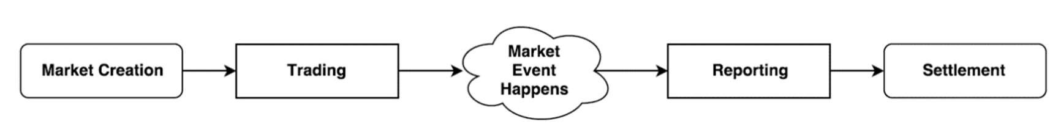
Figure 16: Different Phases in Augur

1) Market Creation
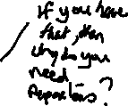
Any user can create a market in Augur for an upcoming event. When creating a market, the user stakes a deposit and sets several parameters. The market creator sets the event end time and a designated reporter who is responsible for reporting the outcome of the event. The market creator also chooses a resolution source, that reporters must use to settle on the outcome. E.g., bbc.com. Besides this, market creators also post two bonds: the validity bond and the designated reporter no-show bond. The validity bond is staked in Ether, which incentivizes market creators to create well defined markets that have unambiguous outcomes. The size of the validity bond is determined dynamically by Augur, which is essentially a proportion of the invalid outcomes in recent markets. On the other hand, no-show bond encourages market creators to choose a reliable designated reporter. It is also used to cover the gas costs of the first public reporter, provided they report correctly.

2) Trading
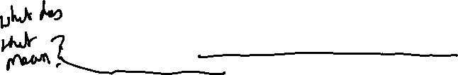
In this phase, users trade shares of market outcomes so as to predict the outcome of events. The automated matching engine of the Augur contract fulfils the trading requests. Request are fulfilled as complete sets by either issuing new complete sets or closing out existing complete sets. Orders are never executed at a worse price than the minimum price set by the seller. Unsuccessful trades can be withdrawn by participants at any time.

3) Reporting
When an event belonging to a market has occurred, the outcome of the event must be determined. The outcome is decided using a decentralized oracle system, which consists of profit motivated reporters who report the actual outcome of the event. Reporters who report correctly are awarded i.e., reports that are consistent with the final outcome and others are penalized. The reporting process can be divided into 6 different stages: designated reporting, open reporting, waiting for the next fee window, dispute round, fork and finalized.

Designated Reporting
Once the event end time has passed, the market enters the designated reporting phase, where the designated reporter specified during market creation has up to three days to report on the outcome of the market’s underlying event. If the designated reporter fails to report within the three-day period, the market creator forfeits his/her no-show bond and the market enters the open-reporting phase. And, if the designated reporter reports on time, the no-show bond is returned to the market creator. When reporting, the designated reporter is required to stake a deposit which they forfeit if the market finalizes to an outcome apart from the one, they reported. After the designated reporter submits a report, the market enters the ‘waiting for the next fee window’ phase.

Open Reporting
If the designated reporter fails to report at the right time, the market enters the open reporting phase and any user can report on the outcome. Also, the market creator forfeits the no-show bond, because the designated reporter was not reliable. The user who first reports on the outcome is called the market’s first public reporter, who receives the no-show bond as a reward for the report they submitted. They may claim the reward only when the market’s final outcome coincides with the outcome they reported. The first public reporter does not have to stake any REP to report on an outcome, which incentivizes participants to report quickly, after the market has entered the open reporting phase.

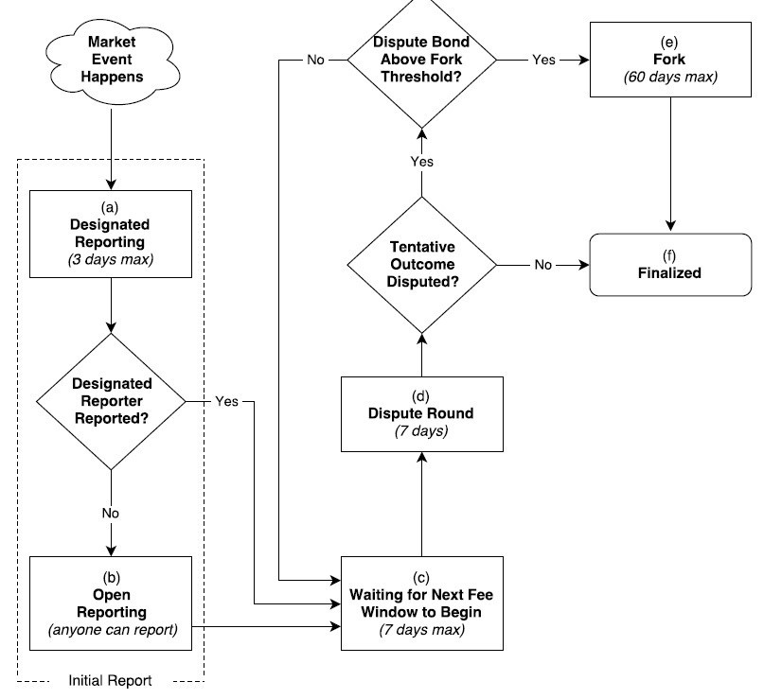
Figure 17: Augur's Reporting Flowchart

Waiting for the Next Fee Window
Once the first report has been submitted, the reporting process is on hold until the end of the current fee window. When the current window period ends, the disputing phase begins.

Dispute Round
The dispute round is a 7-day interval during which users holding REP tokens have the privilege to dispute the market’s tentative outcome. The tentative outcome of the market becomes the final outcome if it is not successfully disputed in the 7-day period. A successful dispute is one where a REP token holder deposits a stake on an outcome other than the market’s tentative outcome. The size of the deposit to be staked in order to successfully dispute the tentative outcome in favour of a new outcome w during round n is denoted by B(w, n) and is given by:
B(w, n) = 2An – 3S(w, n)
Where An denotes the total stake on all the market’s outcomes at the beginning of round n and S(w, n) is the total stake on outcome w at the beginning of round n. The size of the deposit is chosen this way to ensure a fixed ROI of 50 percent for reporters who successfully dispute false outcomes. Augur also permits collaboration among participants to stake deposits and dispute an outcome. If an outcome is successfully disputed, then the market either enters another dispute round or a fork state. The market enters a fork state if the total size of the dispute bond is greater than 2.5 percent of all the REP available in the system. If the 7-day dispute round ends without a successful dispute, then the market enters the finalized state. The final outcome of a market is the tentative outcome that clears the dispute round without a successful dispute, or the outcome arrived at after a fork. Based on the final outcome, the augur contract distributes the rewards to the reporters who supported the final outcome.

Fork
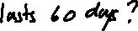
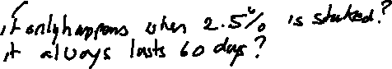
The fork state lasts for a total of 60 days and occurs when a market is successfully disputed with a stake of more than 2.5 percent of all the available REP. Forking creates a new child universe for each outcome that is successfully disputed. E.g., a binary forking market has three 3 child universes: universe A, universe B and universe Invalid. A fork permanently locks the parent universe and there after no new markets are allowed to be created until the underlying market has resolved. During the fork period holders of REP token migrate to the universe of their choice. Also, reporters who staked for a particular outcome in the parent universe cannot alter change positions during migration. The universe that receives the most migrated REP at the end of the forking interval becomes the winning universe and its corresponding outcome becomes the final outcome of the market. Unfinalized markets are only allowed to migrate to the winning universe. The system provides 5 percent additional tokens to all token holders who migrated their REP during the forking period, to encourage greater participation.

Finalized
A market enters the finalized state if it passes through a 7-day dispute round without a successful dispute or as the completion of a fork. The outcome of a fork is considered final and cannot be further disputed. The traders settle their positions after their markets enter the finalized state.

4) Market Settlement
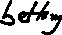
In this phase, traders close their positions by either selling their shares to another trader in exchange for currency or by settling their shares in the market. Augur levies fees such as the creator fee and the reporting fee, on participants during settlement. All the REP staked on an outcome other than the final outcome is forfeited and redistributed to participants who supported the final outcome, in proportion to the amount of REP they deposited.
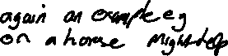
3.4 A Summary of Oracles

Bibliography
- Kolb, J., Abdelbaky, M., Katz, R. H., & Culler, D. E. (2020). Core Concepts,
Challenges, and Future Directions in Blockchain: A Centralized Tutorial. ACM
Computing Surveys, 53(1), 1–39. https://doi-org.elib.tcd.ie/10.1145/3366370
- Satoshi Nakamoto. (2009). Bitcoin: A Peer–to–Peer Electronic Cash System.
Retrieved from: https://bitcoin.org/bitcoin.pdf .
- Vitalik Buterin. (2014). A Next-Generation Smart Contract and Decentralized Application Platform. Retrieved from: https://github.com/ethereum/wiki/wiki/White-Paper .
- Feng, T., Yu, X., Chai, Y. and Liu, Y. (2019). Smart contract model for complex reality transaction. International Journal of Crowd Science, Vol. 3, pp. 184-197.
- M. Merlini, N. Veira, R. Berryhill and A. Veneris. (2019). On Public
Decentralized Ledger Oracles via a Paired-Question Protocol. IEEE International Conference on Blockchain and Cryptocurrency (ICBC), Seoul, Korea (South), pp.
337-344.
- Provable [Online]. Available: https://docs.provable.xyz/
- Karame, G.O., & Audroulaki, E. (2016). Bitcoin and Blockchain Security.
- Zhang, Fan & Cecchetti, Ethan & Croman, Kyle & Juels, Ari & Shi, Elaine. (2016). Town Crier: An Authenticated Data Feed for Smart Contracts. Retrieved from: https://eprint.iacr.org/2016/168.pdf
- V. Costan and S. Devadas, “Intel sgx explained.” IACR Cryptology ePrint Archive, vol. 2016, no. 086, pp. 1–118, 2016.
- Berberich, M.; Steiner, M. (2016). Blockchain technology and the gdpr how to reconcile privacy and distributed ledgers. European Data Protection Law Review (EDPL), 2(3), 422-426.
- Blockchain Oracles Explained. Available: https://www.binance.vision/blockchain/blockchain-oracles-explained
- Bitcoin’s UTXO Set Explained. Available: https://www.mycryptopedia.com/bitcoin-utxo-unspent-transaction-output-setexplained/
- Full Node. Available: https://en.bitcoin.it/wiki/Full_node
- Unspent transaction output. Available: https://en.wikipedia.org/wiki/Unspent_transaction_output
- Domain Name System. Available: https://en.wikipedia.org/wiki/Domain_Name_System
- Remote Procedure Call. Available: https://en.wikipedia.org/wiki/Remote_procedure_call
- Dr. Gavin Wood. (2019). Ethereum: A secure decentralised generalised transaction ledger byzantium version. Retrieved from: https://ethereum.github.io/yellowpaper/paper.pdf
- Vitalik Buterin. (2013). Ethereum Whitepaper. Retrieved from: https://ethereum.org/whitepaper/
- Antonopoulos, A. M., & Wood, G. (2018). Mastering Ethereum: Building smart contracts and DApps.
- Patrick Dai, Neil Mahi, Jordan Earls, Alex Norta. Smart-Contract ValueTransfer Protocols on a Distributed Mobile Application Platform. Retrieved from: https://old.qtum.org/en/white-papers
- QTUM Blockchain New Whitepaper. (2020). Retrieved from: https://qtum.org/en/developer
- Proof of stake. Retrieved from: https://en.wikipedia.org/wiki/Proof_of_stake
- Sin Kuang Lo, Xiwei Xu, Mark Staples, Lina Yao. (2020). Reliability analysis for blockchain oracles. Volume 83.
- Abdeljalil Beniiche. (2020). A Study of Blockchain Oracles. Retrieved from: https://deepai.org/publication/a-study-of-blockchain-oracles
- Nash Equilibrium. Retrieved from: https://en.wikipedia.org/wiki/Nash_equilibrium
- John Adler, Ryan Berryhill, Andreas Veneris, Zissis Poulos, Neil Veira, and Anastasia Kastania. (2018). ASTRAEA: A Decentralized Blockchain Oracle.
Retrieved from: https://www.eecg.utoronto.ca/~veneris/18chain1.pdf
- TLSnotary - a mechanism for independently audited https sessions. (2014).
Retrieved from: https://tlsnotary.org/TLSNotary.pdf.
- Steve Ellis, Ari Juelsy, Sergey Nazarov. (2017). ChainLink - A Decentralized
Oracle Network. Retrieved from: https://link.smartcontract.com/whitepaper
- Jack Peterson, Joseph Krug, Micah Zoltu, Austin K. Williams, Stephanie
Alexander. (2018). Augur: a Decentralized Oracle and Prediction Market Platform
(v2.0). Retrieved from: https://www.augur.net/whitepaper.pdf

